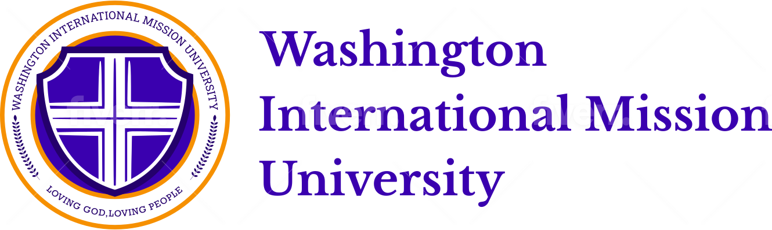

Application

Enrollment Information 등록정보
- First-time student 신입생
- Transferring from another school 전학생
Quarter which you plan to enroll 등록학기
- Fall 가을, 20____
- Winter겨울, 20____
Applying Degree 등록학위
- Certificate of Ministry 사역자격증
- Bachelor of Ministry 학사
- Master of Ministry 사역석사
- Master of Divinity 목회학 석사
- Doctor of Ministry 목회학 박사

- Spring봄, 20____
- Summer여름, 20____

Personal Information 개인정보

Full Legal Name _____________________________________________________________
Last (성) First (이름) Middle Initial Maiden Name
Gender M F
Address 주소___________________________________
Street
____________________________________________________________________ City State Zip
Home Phone _____________________________ Cell Phone ______________________________
Work Phone ______________________________ E-mail address ___________________________
Social Security Number _____________________
Date of Birth ______________________________ Birth Country ___________________________
Country of Citizenship ______________ If not U.S. citizen, what type of visa do you hold? _____________

Foreign Address Information외국주소
Street Address ________________________________________________________
City _________________________________
Postal Code
Country ______________________________

Religious Information 교회정보
Home Church ______________________________ Years of Attendance __________
Mailing Address __________________________________________________________________
Are you currently in ministry? Yes No Position ____________________________
Senior pastor ______________________________ Phone _____________________________
When did you accept Christ as your Savior?
Have you been water baptized? Yes No If yes, when?
Have you received the Baptism of the Holy Spirit? Yes No If yes, when? __________

Educational Experience교육
Date (or anticipated date) of graduation from high/secondary school ___________________ (month/year)
Name and city/state/county of high/secondary school _____________________________
Have you earned a degree from any college or university? Yes No
Name and Date of graduation from college, university, or seminary________________________________________
Degree and Major_______________________________________________________________________________

Financial Request 재정
What is your anticipated source of income while at WIMU?
How much do you need to be assisted? 도움이 필요한 학비$________________________________________

Emergency Contacts비상 연락
Name _____________________________________________
Relationship to you Parent or Guardian
Address ________________________________________________________________________________
Telephone ___________________________________

Name _____________________________________________
Relationship to you Parent, Spouse or Other
Address ________________________________________________________________________________
Telephone ___________________________________

Application Checklist 체크리스트
- Completed application.
- $50.00 non-refundable application fee
- $132/credit for tuition fee, Bachelor of Ministry
- $165/credit tuition, Master of Ministry and Master of Divinity
- $200/credit tuition, Doctor of Ministry.
- Transcript or official records
- Completed references (2 references for Bachelor, and 3 references for Master and Doctor

*Washington International Mission University accepts forms of payment including cash, personal checks from a US bank, money orders and international wire transfers. Credit and debit cards accepted. Please request additional information from the office for international wire transfers.

Note: Washington International Mission University does not discriminate in its admission policies on the basis of race, color, national origin, gender, age, disability, status as a veteran, or any other characteristic protected by law.

Agreement to attend Washington International Mission University By signing the below line, I declare that everything written here is true. If any part is found to be untrue I can be dismissed from Washington International Mission University. I will adhere to being honest, living with integrity, be non discriminatory, and non violent. I will live in a way that will not soil or bring down the reputation of Washington International Mission University or Christianity.

Signed ______________________________________ Date _______________

Office Use Only
Date Received __________ Application Fee Received __________

Scan and email application to:
rhkong@yahoo.com

call for application to:
206-429-2289
Mail completed application and/or payment to:
Washington International Mission University
2808 S 308th Lane
Federal Way, WA 98003
USA

